SpatialModelBenchmark: A robust R workflow for rapid and flexible statistical evaluation of spatial proteomics features
Authors:
Nicole Saw^{1,2}, Cecilia Jensen^{1,3}, Tony Huang^{1,2}, Alex Boussioutas^{1,2,4}, Ian Parish^{1,2}, Athanasios Koulis^{1,2}, David L Goode^{1,2,5}
- Research Division, Peter MacCallum Cancer Centre
- Sir Peter MacCallum Dept of Oncology, University of Melbourne
- School of Engineering, University of Melbourne
- School of Translational Medicine, Monash University
- Dept of Biochemistry & Molecular Biology, Monash University

Abstract (April 2025)
Spatial proteomics is a powerful emerging tool to link spatial context with cell biology for research and discovery. However, the downstream analysis of spatial proteomic data generates complex datasets characterized by diverse statistical distributions. This diversity presents a significant statistical challenge; many current studies rely on non-parametric methods, such as the Wilcoxon test, which often fail to account for critical confounding factors like tissue region and patient identity. Furthermore, existing workflows are limited in their ability to rapidly and flexibly perform large numbers of statistical analyses of multiple cell types in parallel and present the results in an easily understandable manner.
We developed SpatialModelBenchmark, a flexible R framework for performing and benchmarking complex statistical analyses of spatial proteomic data. SpatialModelBM provides a highly customizable interface, allowing users to define input parameters, grouping variables, and statistical frameworks, while also encompassing tools for processing, filtering and statistical analysis of data from multiple distinct cell populations in parallel. SpatialModelBenchmark incorporates parametric and non-parametric tests of population means, generalised linear models (GLMs) and generalised linear mixed models (GLMMs) for selected spatial features such as cell counts and densities from spatial proteomics datasets.
SpatialModelBenchmark also implements GLMM fitting and permutation tests to enable users to benchmark parametric assumption and the Type I error rate of hypothesis testing procedures directly on their data. We demonstrate how the SpatialModelBenchmark framework uncovers important biological features from Opal multiplex-immunohistochemistry (mIHC) and Multiplexed Ion Beam Imaging by Time-of-Flight (MIBI-TOF) data. SpatialModelBenchmark efficiently extracts immune cell types with greatest differences in frequency between sub-groups of triple negative breast cancer patients and macrophage markers whose density varies according to distance from the tumour core in gastric cancer. Our explorations on published data found Negative Binomial had reduced false positive rates over Poisson models, while the Wilcoxon method performed the most consistently across datasets, even when using null data.
Integrated visualisation functions further enable rapid assessment of analysis results to select the most pronounced and significant differences in cell type abundance and clustering between sample groups.
SpatialModelBenchmark introduces a new accessible and fast framework for researchers to gain valuable insights from spatial proteomics, expanding the utility of this important new data modality. By empowering researchers to select optimal statistical tests for novel biological discovery of spatial interactions.

Introduction
Intra‑tumour heterogeneity has been shown to modulate clonal evolution and phenotypic plasticity that confers treatment resistance and tumour progression (Tumeh et al. 2014; Mathis et al. 2017; de Bruin et al. 2014). Traditional bulk DNA and RNA profiling approaches obscure this heterogeneity by homogenising molecular signals across diverse cell populations, thereby masking clinically relevant individual cell states and positions (Ståhl et al. 2016). High‑throughput single‑cell sequencing technologies have provided unprecedented insight into cellular diversity within tumours (Eisenbarth and Wang 2023; Li et al. 2020). However, these approaches require tissue dissociation, resulting in the loss of spatial information that is critical for understanding tissue architecture and interactions between malignant and non-malignant cells (Tirosh et al. 2016). As spatial organisation plays a key role in immune evasion, therapeutic resistance, and tumour progression, approaches that preserve spatial context are essential.
Spatial transcriptomics platforms, such as Xenium and Visium, address this limitation by resolving gene expression within intact tissue sections, thereby resolving spatial niche organisation and proximity between tumour, immune and stromal cells (Ke et al. 2013; Lin et al. 2026; Pentimalli et al. 2025). While these technologies enable spatially resolved gene expression analyses at near single‑cell resolution, RNA abundance does not consistently correlate with protein expression, localisation and post‑translational modifications. Spatial proteomics technologies make it possible to concurrently map the locations of multiple cell types within a single tissue section (Keren et al. 2019; Bollhagen et al. 2025; Navikas et al. 2024; Goltsev et al. 2018). Proteins are labelled in situ to distinguish cell populations that can be further subset by lineage or activity-specific markers (Fan 2024; Method of the Year 2024: spatial prot...). This enables characterisation of cell phenotypes at high resolution, advancing understanding of how spatial context affects cells within their native tissue architectures across multiple domains of biology. These multidimensional datasets are especially promising for decoding the immunobiology in cancer for improved tumour classification and targeted therapeutic strategies (Su et al. 2024; Li et al. 2024)..
Spatial proteomics platforms produce comparable post-segmentation cell-level outputs, including cell coordinates, marker intensities, and inferred phenotypes (Dayao et al. 2022; Czech et al. 2019; McQuin et al. 2018; Shaban et al. 2024). This common data structure enables platform-agnostic downstream analysis in frameworks such as SPIAT, which quantifies spatial features including colocalization, neighborhood structure, heterogeneity, and cell–cell distances (Feng et al. 2023). However, these features also present significant challenges for data analysis and interpretation.
Dozens or even hundreds of statistical comparisons are required per experiment. They are often done in an ad-hoc and sometimes biased manner that is inefficient and can overlook unexpected patterns that may be informative. Further, it is not clear what is optimal for hypothesis testing on spatial proteomics data. Simple t-tests are not appropriate because cell counts and density measurements usually do not meet the assumptions of a normal distribution. Non-parametric tests such as the Wilcoxon rank-sum test are popular but may lack the flexibility needed more complex study designs where multiple tissue sections and/or regions are assayed across patients or experiments (Keren et al. 2018; Ajaib et al. 2025; Wang et al. 2023; Meylan et al. 2026). This limitation is particularly problematic in clinically relevant settings, such as treatment‑resistance studies, where longitudinal sampling from the same patient is common (Ajaib et al. 2025; Wang et al. 2023; Meylan et al. 2026).
Generalised linear mixed-effects models (GLMMs) provide an alternative, which incorporates random effects that model sample- and patient-level dependence. However, these models remain parametric and typically assume a specific response distribution, so they may be less suitable for certain data formats and experimental designs. The complexity of spatial data highlights the need for flexible, user-friendly analytical tools that empower investigators to apply robust parametric models.
To address these challenges, we developed SpatialModelBenchmark, a R framework for implementation and benchmarking of hypothesis testing methods for spatial proteomics data. SpatialModelBenchmark enables researchers to systematically apply pairwise Wilcoxon rank-sum tests, or generalized linear models (GLMs) and generalized linear mixed models (GLMMs) able to account for complex multi-factor analyses and variability across patients and tissue sections. Comparisons of the frequencies and properties of multiple cell types are automatically performed in parallel between and within samples. Benchmarking through permutation testing gauges the stability and power of different hypothesis testing methods on the data provided. Streamlined tools facilitate data filtering and visualization of test results, allowing users to quickly extract significant and meaningful results across all comparisons.

Methods
Overview of SpatialModelBenchmark
We developed and utilized an R package framework, SpatialModelBenchmark, which enables users to decide input and output directories, multiple statistical tests and covariates, and to evaluate model robustness with permutation testing diagnostic reporting. The complete comparative and benchmarking pipeline can be executed as a single-step function, run_spatial_benchmark(). [Figure 1].

. The Wilcoxon rank-sum test is a non-parametric method that compares sample ranking between two groups, without assuming any statistical distribution. Across published studies,Wilcoxon test has been widely utilized to compare marker expression or cell densities between conditions. However, the Wilcoxon test may lack statistical power compared to parametric tests especially when the data distribution fits well into a specific statistical distribution. Moreover, Wilcoxon tests omit crucial covariates beyond group identity.
Generalized Linear Models (GLMs) can be powerful for modelling relationships between cell counts and other predictors such as tissue regions, protein markers or patient characteristics. GLMs are flexible in their ability to handle data from a wide range of statistical distribution beyond the Normal. Examples include negative binomial distribution and poisson distribution, which was tailored for modelling positive integer data such as cell count with a fixed spatial area, negative binomial accounting for potential overdispersion.
Similar to the Wilcoxon test, a simple GLM does not account for the hierarchical or nested study designs often encountered in spatial proteomics, such as multiple ROIs per patients, and each patient may contribute a different number of ROIs with varying sizes. . Generalized Linear Mixed Models (GLMMs) can be useful to account for baseline random biological covariates (patient of origin) to capture true signal between fixed groups (e.g. tissue regions). However, these models remain parametric and typically assume a specific response distribution, so they may be less suitable for certain data formats and experimental designs.
The Wilcoxon test, GLMs and GLMMs are all used in the analysis of spatial ‘omics data [refs]. However, no firm guidelines exist as to which test is most appropriate for a given application. That decision is up to the investigator and depends on the size, complexity and goals of their study. To help guide decision making about choice of hypothesis testing method, SpatialModelBenchmark provides capability to evaluate the performance of each type of test on a given spatial proteomics data set with respect to Type I error rate. A permutation approach is applied to estimate the risk of a false positive result indicating a significant difference exists in the abundance of a cell type between conditions when cellular abundances are in fact equivalent.

Data preparation and input
The input dataset must contain identifiers for the source of the ROI (e.g., patient/sample ID), together with columns relevant to the analysis such as ROI area for calculation of densities and as offset for the GLM and GLMM modelling. Crucially, the users need to define the test column specifying the groups or factors each ROI belongs to, and the spatial features (e.g. cell counts/densities) thatwill be used for subsequent hypothesis testing [Figure 1].
The path to the dataset, alongside with the key columns and statistical models can all be defined by the main run_spatial_benchmark() function. There are also options for including covariates and technical offsets, while also excluding specific groups.
Statistical comparisons
The structure of the data with respect to the numbers and features of the ROIs included for each sample are first graphically summarised with the dataSummary function. Next, the values of selected spatial features are compared between all pairwise combinations of the test column. Statistical tests are performed using the testWilcox() and testGLMM() functions. The testWilcox conducts non-parametric Wilcoxon tests automatically, while the testGLMM() function executes the user-defined GLM or GLMM models. Note that the choice of GLM and GLMM depends on the GLMM_model input parameters. Users can specify the GLMM random effects within the parameter, while an empty string would be equivalent to a simple GLM.
Visualization of statistical testing results
After executing all default and selected testing methods, SpatialModelBenchmark extracts nominal p-values into a simplified matrix with getPvalues() and conducts the Benjamini-Hochberg correction for multiple hypothesis testing via the adjustPvalues() function [Figure 1].

The adjusted p-values, together with the mean log2 fold change extracted by the compute_lfc() function, are visualised in the form of a heatmap via the pvalueHeatmap_directional() function [Figure 1]. The magnitude of the p-value is proportional to colour intensity, with p-values below 0.05, 0.01 and 0.001 marked by asterisks on the plot. Meanwhile, red and blue colours represent positive and negative log2 fold change over control group, respectively. The groups compared in each test are represented by the row annotation while the features under consideration is shown in the row text label. The heatmaps can be shown either as a single heatmap, or a stacked heatmaps if there were multiple pairwise comparisons. The columns represent all executed statistical tests. Features that are statistically significant in at least one test (FDR < 0.05) were further visulaised as groupwise violin plots using the render_violin_plot() function. The heatmap enables users to identify at a glance the results that endure multiple hypothesis test correction and evaluate the extent and nature of differences in cell type abundances between the samples groups defined in their studies. SpatialModelBenchmark thus facilitates rapid, in-depth interpretation of the outcomes of hypothesis testing on complex spatial proteomics data sets.
Automated Model Diagnostics and Quality Control
The modelQC() function performs quality control and diagnostic testing on statistical models contained within specified columns of a dataframe. Leveraging the DHARMa and tidyverse packages, it iterates through the specified model columns to generate simulated residuals (or maps existing simulation inputs) and runs diagnostic checks including Kolmogorov-Smirnov (KS) uniformity, dispersion, and outlier tests. It then renders diagnostic QQ plots containing the extracted test results, with any significant model misfits highlighted in red.
Benchmarking performance of hypothesis data methods through data permutation
SpatialModelBenchmark also contains built-in permutation functions to evaluate the robustness of the applied statistical tests. The shuffleData() function randomly shuffles group labels or spatial coordinates while preserving dataset structure to generate null datasets lacking true biological signals. SpatialModelBenchmark’s hypothesis testing can then be applied to these null datasets. The number of permuted data sets used for testing is under the user’s control, though a minimum of 100 permutations is recommended. The resulting distributions of null p-values or test statistics are compared to those of the original data by the countSignificant()function. By default it reports the number permuted data sets achieving a p < 0.05 but significance threshold can be set by the user. The number of null p-values reaching significance can be visualized using sigcountHeatmap() for each sample set and comparisons.
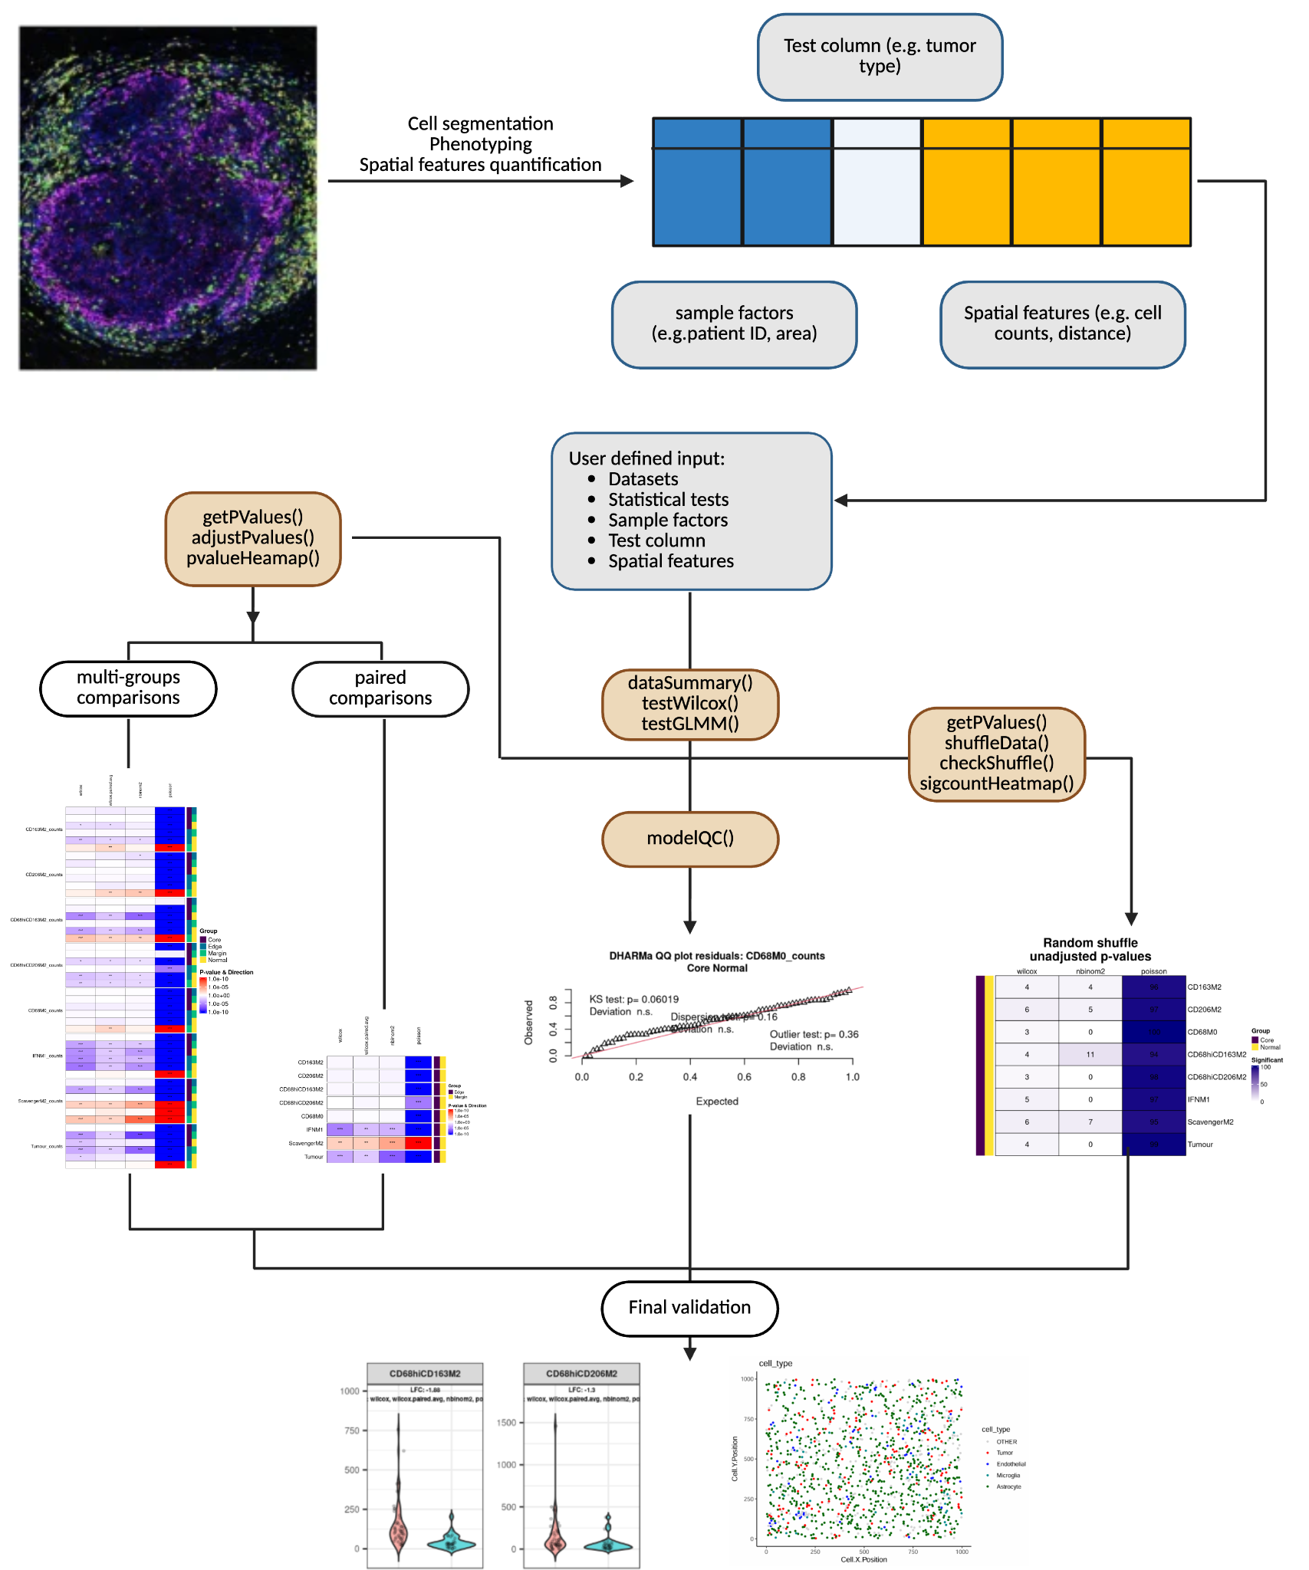
Figure 1: Outline of the data analysis workflow for SpatialModelBenchmark.

Use Cases
Pairwise Comparison of Triple Negative Breast Cancer Patients Stratified by Immune Subtype
To demonstrate the structure and capabilities of the SpatialModelBenchmark workflow, we begin with an example analysis of MIBI data from 36 tumours from triple negative breast cancer (TNBC) patients, published by Keren et al in 2018 [ref]. The TNBC dataset comprises cell counts from patients with mixed or compartmentalised tumours, defined by composition of tumour-immune cell populations and overall immune infiltration. MIBI data are available from 41 tissue sections in total with 36 tumor and immune marker proteins profiled in each. A single tissue section of size 800um² was assayed from each patient, and each tissue section is imaged in whole. For simplicity, we subset the data for tissue sections labelled as having mixed or compartmentalised tumours and perform comparisons between those two patient groups.
The "cellData_with-centroids.csv" data file was downloaded directly from the public Angelo lab site linked here. Closely following the procedure by Feng et al (Git hub link paper), using the SPIAT R package (ref) TNBC raw MIBI counts we pre-processed and saved as MIBI_spe.Rda. After filtering, the remaining data is now composed of 31 rows, one for each tissue section. Filtered data and code used for pre-processing steps are available on the SpatialModelBenchmark Github repository.

Discussion
A robust testing workflow is crucial for ensuring that multiple hypothesis testing yields reliable and interpretable results. The choice of statistical model plays a central role in this workflow, with different methods tailored to address specific dataset characteristics. For instance, the Wilcoxon rank-sum test is a robust, non-parametric approach suitable for small datasets or when assumptions of normality are not met. It provides a straightforward method for comparing marker expression or cell densities between conditions, making it ideal for exploratory analyses. By contrast, generalised linear models (GLMs) and generalised linear mixed models (GLMMs) are better suited for hypothesis-driven research. GLMs are efficient for simpler comparisons, while GLMMs account for complex data structures, such as within-study heterogeneity (e.g. multiple measurements per patient, different sizes of tissue samples).

This paper provides a comprehensive guide for researchers to adapt the SpatialModelBenchmark workflow for a specific spatial proteomics research question. We outline each step in our framework with example analyses on MIBI-TOF data from triple-negative breast cancer (TNBC) and OPAL multiplex immunohistochemistry (mIHC) data mapping tumour-associated macrophages (TAMs) in gastric cancer. The results demonstrate how SpatialModelBenchmark facilitates robust, reproducible, and interpretable spatial analyses that can accommodate complex experimental designs and variable formats of spatial data.

Our decision to benchmark Negative Binomial and Poisson models stems from their differing assumptions and performance under real-world conditions. Poisson models are computationally simpler but often prone to false positives in overdispersed data. Negative Binomial models, while more conservative, provide greater robustness, particularly in datasets with substantial variability in cell counts or densities. By comparing these models, we aim to guide researchers in performing their own comparisons to select the most appropriate framework for their analyses. Simulated and null datasets play a critical role in this benchmarking process, enabling controlled comparisons that assess model performance under both expected and null conditions. This ensures that models reliably detect true patterns while reducing false significance. [General Testing Workflow figure]. As spatial proteomics platforms become more versatile and accessible, a wider spectrum of potential applications can be expected.

